 | 26.9.8 Editors - Geometry Nodes Editor - Header - Add Modifier Menu - Hair - Guides modifiers
Table of content
Detailed table of content 1
Hair - Guides modifiers 3
General functionality 3
Braid Hair Curves 4
Clump Hair Curves 6
Curl Hair Curves 7

Detailed table of content
Detailed table of content
Detailed table of content 1
Hair - Guides modifiers 3
General functionality 3
Output Attributes 3
Internal Dependencies 4
Bake 4
Named Attributes 4
Braid Hair Curves 4
Guide Distance 4
Guide Mask 4
Existing Guide Map 4
Factor 4
Subdivision 4
Braid Start 4
Radius 4
Shape 4
Factor Min 4
Factor Max 5
Frequency 5
Thickness 5
Thickness Shape 5
Shape Assymetry 5
Flare Length 5
Flare Opening 5
Hair Tie Object 5
Hair Tie 5
Hair Tie Scale 5
Output Attributes 5
Guide Index 5
Flare Parameter 5
Strand Index 5
Internal Dependencies 6
Named Attribute 6
Clump Hair Curves 6
Guide Distance 6
Guide Mask 6
Existing Guide Map 6
Factor 6
Shape 6
Tip Spread 6
Clump Offset 6
Distance Falloff 6
Distance Threshold 6
Preserve Length 6
Output Attributes 7
Guide Index 7
Flare Parameter 7
Strand Index 7
Internal Dependencies 7
Named Attribute 7
Curl Hair Curves 7
Guide Distance 7
Guide Mask 7
Existing Guide Map 7
Factor 7
Subdivision 7
Curl start 7
Radius 7
Factor Start 8
Factor End 8
Frequency 8
Random Offset 8
Seed 8
Output 8
Geometry 8
Output Attributes 8
Guide Index 8
Internal Dependencies 8
Named Attribute 8

Hair - Guides modifiers

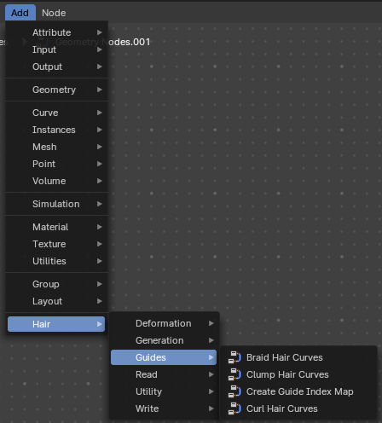
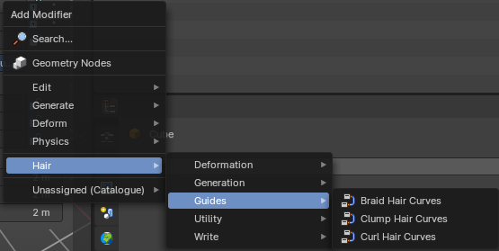

Hair nodes are Geometry node groups found in the Essentials Library included with Bforartists. They differ from the other nodes in the add menu due to being mid level node groups instead of individual low level nodes.
These hair nodes are also available as Modifiers. And this modifier adds the same node group as you would do it in the geometry node editor. Which means you can control these node groups in the modifier stack now instead of the geometry node editor.
Note that hair curves is usually a mesh only functionality. But shows for all other object types too.


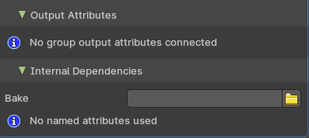
General functionality
All Hair nodes have an Output Attributes and Internal dependencies tab. If the hair node has output attributes or internal dependencies depends of the hair node.

Output Attributes
Contains group output attributes in case the node group has any. It is usually the output of the nodes besides the geometry.

Internal Dependencies

Bake
Define a bake name and a bake folder.
TODO: find out how this is meant to work.

Named Attributes
Named attributes of the hair node group in case the group has any.

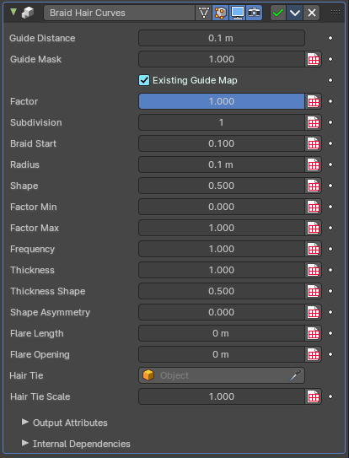
Braid Hair Curves
Deforms existing hair curves into braids.

Guide Distance
Minimum distance between two guides for new guide map.

Guide Mask
Mash for which curve are eligible to be selected as guides.

Existing Guide Map
Use the existing guide map attribute if available

Factor
Factor to blend overall effect.

Subdivision
Subdivision level applied before deformation.

Braid Start
Where to start to blend deformation in percent from the root.

Radius
Overall radius of the braids.

Shape
Shape of the braid radius along each curve.

Factor Min
Minimum radius of the braid.

Factor Max
Maximum radius of the braid.

Frequency
Frequency factor of the braids.

Thickness
Thickness of the braids.

Thickness Shape
Shape adjsutment of the strand thickness for the braids.

Shape Assymetry
Asymetry of the shape adjustment of the strand thickness.

Flare Length
Length of the flare at the end of the braid.

Flare Opening
Opening radius of the flare at the tip of the braid.

Hair Tie Object
Object used for the hair tie instance.

Hair Tie
Geometry used for the hair tie instance. This has priority.

Hair Tie Scale
Scale of the hair tie instance.

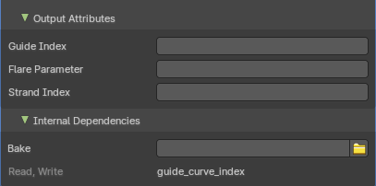
Output Attributes

Guide Index
The guide index map that was used for the operation.

Flare Parameter
Parameter between 0 and 1 along the flare.

Strand Index
Index of the strand within a braid that each curve belongs to.

Internal Dependencies

Named Attribute
Read and Write attribute with name guide_curve_index

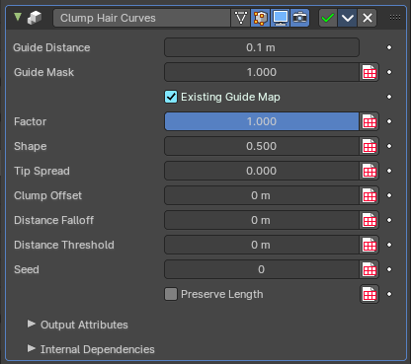
Clump Hair Curves
Clumps together existing hair curves.

Guide Distance
Minimum distance between two guides for new guide map.

Guide Mask
Mash for which curve are eligible to be selected as guides.

Existing Guide Map
Use the existing guide map attribute if available.

Factor
Factor to blend overall effect.

Shape
Shape of the influence along curves. 0 means constant. 0.5 means linear.

Tip Spread
Distance of random sread at the curve tips

Clump Offset
Offset of clump in a random direction.

Distance Falloff
Falloff distance for the clumping effect. 0 means no falloff.

Distance Threshold
Distance threshold for the clumping effect. 0 means no falloff.

Preserve Length
Preserve the length of each curve during deformation.

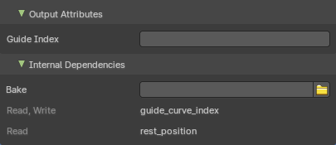
Output Attributes

Guide Index
The guide index map that was used for the operation.

Flare Parameter
Parameter between 0 and 1 along the flare.

Strand Index
Index of the strand within a braid that each curve belongs to.

Internal Dependencies

Named Attribute
Read and Write attribute with name guide_curve_index
Read attribute with name rest_position

Curl Hair Curves
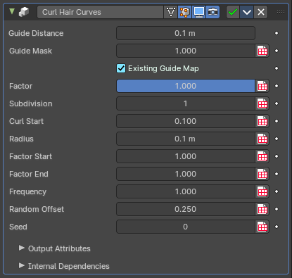
Deform existing hair curves into curls.

Guide Distance
Minimum distance between two guides for new guide map.

Guide Mask
Mash for which curve are eligible to be selected as guides.

Existing Guide Map
Use the existing guide map attribute if available.

Factor
Factor to blend overall effect.

Subdivision
Subdivision level applied before deformation.

Curl start
The curl start point.

Radius
The curl radius.

Factor Start
Form where to blend deformation in percent, starting from the root.

Factor End
Factor for the radius at the curl end.

Frequency
Frequency factor of the curls.

Random Offset
Amount of random offset per curve.

Seed
Random seed for the operation.

Output

Geometry
The output geometry.

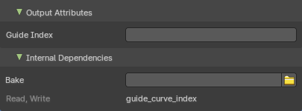
Output Attributes

Guide Index
The guide index map that was used for the operation.

Internal Dependencies

Named Attribute
Read and Write attribute with name guide_curve_index

